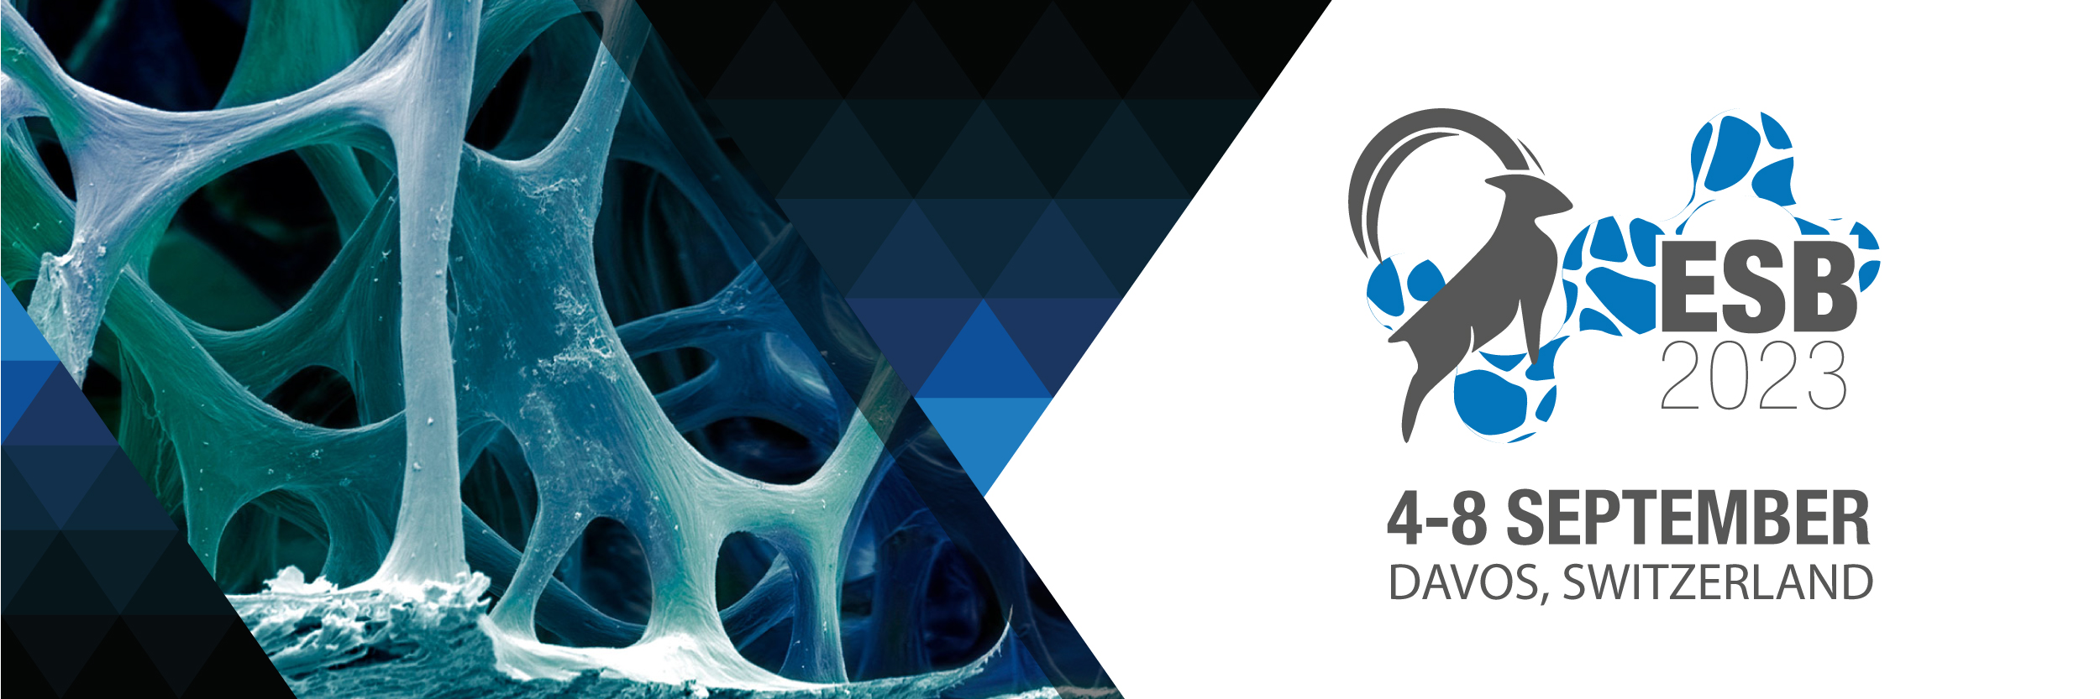

Dear Colleagues,

We are glad to inform you that the preparations for the ESB2023 conference are in full swing. The conference Chairs David Eglin, Marcy Zenobi-Wong and Matteo D'Este with the support of the Local, the National and the Program Committees are working on organizing logistics and scientific program. We are proud to have secured 4 extraordinary plenary speakers: Jennifer Elisseeff, Michaela Kneissel, Tatiana Segura and Amir Zadpoor https://esb2023.org/plenary-speakers/. Confirmed keynote speakers up to date include Maartje Bastings, Laura De Laporte, Una Fitzgerald Warren Grayson, Marleen Kamperman, Daniel Kelly, Michael Levin and Claudia Loebel, covering a wide spectrum of topics at the forefront of biomaterials research, but also side topics, such as implementing best practices in sustainability in biomaterials laboratories.
You all have the opportunity to shape the program: the Call for Symposia for ESB2023 is still open. Symposia provide a forum for focused discussions on new and emerging topics or innovative applications of established approaches. A symposium may revolve around a specific theme, or it may highlight the work done by societies or international consortia. Proposals must be submitted until December 15th, 2022.
Davos is a renowned mountain resort in Eastern Switzerland delivering a unique combination of urban flavor surrounded by glorious nature. At this point in time hotel prices are still low, and many of them offer free cancellation policy, and therefore we recommend securing a bargain accommodation price by booking now.

The Conference Team is looking forward to welcoming you to Davos!

For more information or any further questions: esb.davos@aofoundation.org

